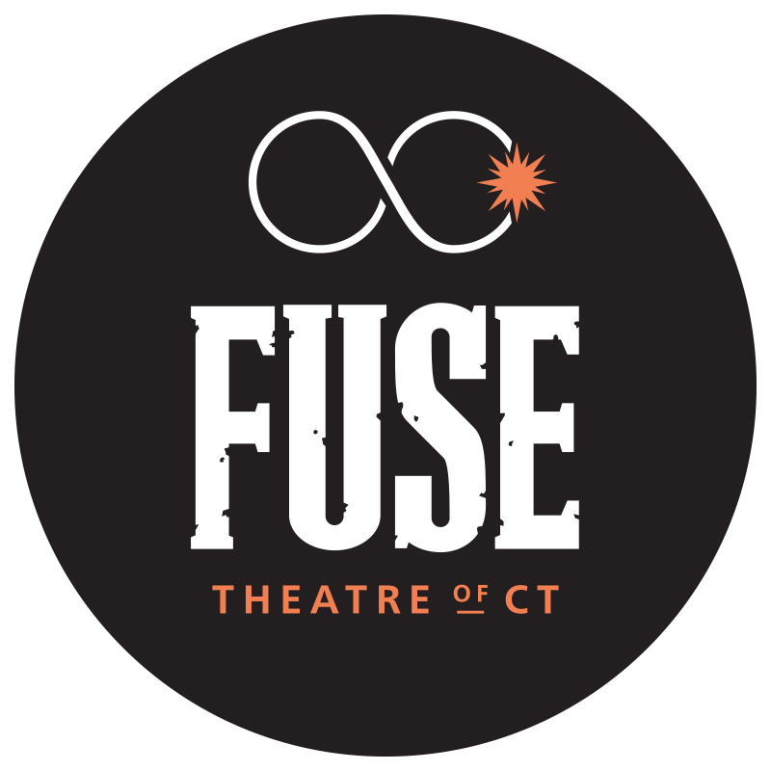
Event Press Release

FUSE Theatre of CT, Inc.
Contact: Lara Morton, Artistic Director
Ph. 203-314-3394
E: info@fusetheatrect.org

FOR IMMEDIATE RELEASE

FUSE Theatre of CT Presents Kimberly Belflower’s ‘Lost Girl.’

West Haven, CT: FUSE Theatre of CT will present Kimberly Belflower's play "Lost Girl" on July 22 and July 23 at Gateway Christian Fellowship in West Haven, CT. "Lost Girl" is a gorgeous new work by the award-winning, up-and-coming American playwright Kimberly Belflower, based on the continued story of Wendy Darling from J.M. Barrie's "Peter Pan." Years after returning from her adventure in Neverland, Wendy remains fixated on her beloved Peter and the childhood magic she left behind. Can Wendy face finally leaving her nursery and learn what it really means to grow up? "Lost Girl" is a lyrical exploration of finding love, overcoming trauma and entering adulthood. BroadwayWorld says it "draws the audience in through this story we've heard a dozen times before, then winds up bringing the high-flying fantasy back to solid ground. It's refreshing, bold, and brave to take such iconic characters into a new and very real place, teeming with the big, wild emotions of adolescence."
For further information and to purchase tickets, visit fusetheatrect.org. Tickets are $15. Seating is general admission. We offer a $10 discount for purchases of more than five tickets. "Lost Girl" will be performed Friday, July 22 at 7:30 p.m. and Saturday, July 23 at both 3 p.m. and 7:30 p.m. Gateway Christian Fellowship is located at 129 Bull Hill Lane, West Haven. Masks will be required for all audience members.
Fuse Theatre of CT's "Lost Girl" is directed by Lara Morton. It features original underscoring by Lydia Arachne (of the Connecticut band Semaphora), costume design by Jake Egan O'Hara, and movement by Susan Dresser. Keona Gomes serves as assistant and technical director with C.J. Burdo stage managing. "Lost Girl" is produced by Noah Golden and Elizabeth Santaus. The cast features Abigail Page (as Wendy Darling), Andrew James Bleidner (as Peter/Slightly), DeMarie Lopez (as Nibs/Detective), Emma Blanchette (as B/Callie), Riley Arenberg (as Mother/Nina), Serena McFarland (as C/Krista), Emma Bender (as Curley/Doctor), Gwen Gersick-Seward (as A/Cora), Dyllan Siegmund (as Tootles/Therapist), and Justin Wargo (as Boy).

ABOUT US: FUSE Theatre of CT is a 501 (c)3 non-profit theatre company serving the Greater New Haven Area. Co-Founded in 2019 by Lara Morton and Susan Larkin, FUSE is committed to promoting the highest standards in the art of theater production and education. Past projects include the musical revue “All Together Now” in November 2021 and “A Midsummer Night's Dream: The Rewired Musical,” a film adaptation of the Shakespeare classic set during quarantine and featuring original songs by Lydia Arachne. FUSE continues their 2022 season with “Songs for A New World,” a song cycle by Jason Robert Brown in the fall (dates and locations TBA).

“Lost Girl” by Kimberly Belflower is a Samuel French title, presented by special arrangement with Concord Theatricals.

